**SELECT**

**SUM(F.FATAL_MEASURE), h.year, h.month**

**FROM**

**collision_fact F, hours H, accident A**

**WHERE**

**A.accident_key = F.accident_key AND**

**F.hour_key = H.hour_key AND A.environment like '%Snow'**

**group by**

**rollup(h.year, h.month)**

**SELECT**

**SUM(F.FATAL_MEASURE), h.year, h.month, a.road_surface**

**FROM**

**collision_fact F, hours H, accident A**

**WHERE**

**A.accident_key = F.accident_key AND**

**F.hour_key = H.hour_key AND H.hour_start > 10**

**group by**

**rollup(h.year, h.month, a.road_surface)**

***1. Drill down, roll up:***

For instance, determine the total number of fatalities in Ottawa During the four years.

**SELECT**

**SUM(F.FATAL_MEASURE)**

**FROM**

**collision_fact F, hours H**

**WHERE**

**F.hour_key = H.hour_key**

For instance, determine the total number of fatalities in Ottawa during 2015.

**SELECT**

**SUM(F.FATAL_MEASURE)**

**FROM**

**collision_fact F, hours H**

**WHERE**

**F.hour_key = H.hour_key AND H.year = 2015**

For instance, determine the total number of fatalities during an ice storm in Ottawa during 2014.

**SELECT**

**SUM(F.FATAL_MEASURE)**

**FROM**

**collision_fact F, hours H, accident A**

**WHERE**

**F.hour_key = H.hour_key AND H.year = 2014 AND A.accident_key = F.accident_key AND A.environment like '%Snow'**

For instance, determine the total number of fatalities during a snow storm in Ottawa during December 2014.

**SELECT**

**SUM(F.FATAL_MEASURE)**

**FROM**

**collision_fact F, hours H, accident A**

**WHERE**

**F.hour_key = H.hour_key AND A.accident_key = F.accident_key AND**

**H.year = 2014 AND H.month = '12' AND A.environment like '%Snow'**

For instance, determine the total number of fatalities during a snow storm in Downtown Ottawa during 2014.

**SELECT**

**SUM(F.FATAL_MEASURE)**

**FROM**

**collision_fact F, hours H, accident A , locations L**

**WHERE**

**F.hour_key = H.hour_key AND L.location_key = F.location_key AND A.accident_key = F.accident_key AND H.year = 2014 AND H.month = '12' AND A.environment like '%Snow' AND L.neighbourhood = 'centertown'**

***2. Drill down, roll up, slice and dice***

For instance, compare the number of accidents on Mondays, versus the number of accidents on Fridays.

**select**

**count(*) filter (where h_dim.day_of_week = 'Monday') as Monday_accidents,**

**count(*) filter (where h_dim.day_of_week = 'Friday') as Friday_accidents**

**from collision_fact cf, accident a_dim, hours h_dim**

**where cf.accident_key = a_dim.accident_key**

**and cf.hour_key = h_dim.hour_key;**

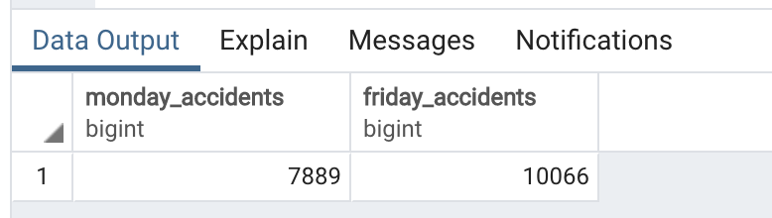

For instance, compare the number of fatal accidents on Mondays, versus the number of fatal accidents on Fridays.

**select**

**count(*) filter (where h_dim.day_of_week = 'Monday') as Monday_fatals,**

**count(*) filter (where h_dim.day_of_week = 'Friday') as Friday_fatals**

**from collision_fact cf, accident a_dim, hours h_dim**

**where cf.accident_key = a_dim.accident_key**

**and cf.hour_key = h_dim.hour_key**

**and cf.fatal_measure = 1;**

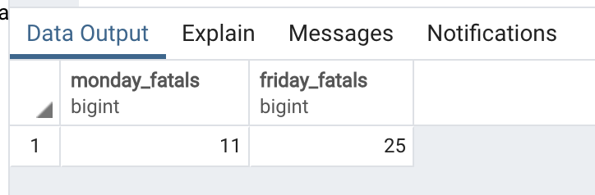

For instance, contrast the number of accidents at intersections, versus those that do not occur at intersections.

**select**

**count(*) filter (where cf.intersection_measure = 1) as at_intersection,**

**count(*) filter (where cf.intersection_measure = 0) as not_at_intersection**

**from collision_fact cf;**

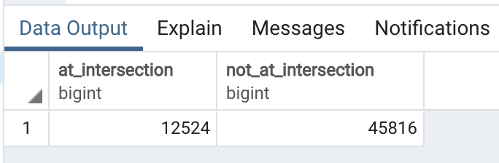

For instance, contrast the number of fatal accidents at intersections versus those that do not occur at intersections.

**select**

**count(*) filter (where cf.intersection_measure = 1) as fatals_at_intersection,**

**count(*) filter (where cf.intersection_measure = 0) as fatals_not_at_intersection**

**from collision_fact cf**

**where cf.fatal_measure = 1;**

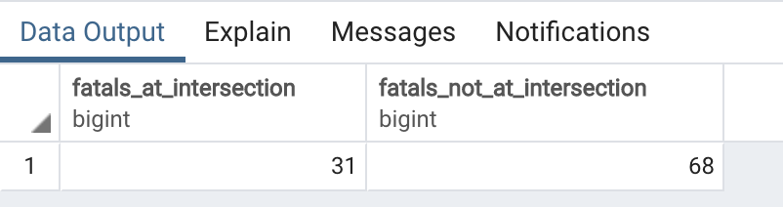

***3. Explore the interplay between weather conditions and accidents, focussing on traffic control, intersection, impact type and visibility.***

For instance, contrast the total number of accidents during summer, with the number of fatalities during fall.

**select**

**count(*) filter (where h.month = '6' OR h.month = '7' OR h.month = '8' OR h.month = '9') as summer,**

**count(*) filter (where h.month = '10' OR h.month = '11' OR h.month = '12' AND cf.fatal_measure = 1) as fall**

**from collision_fact cf, hours h, accident a**

**where cf.hour_key = h.hour_key and cf.accident_key = a.accident_key**

For instance, determine the interplay between road surface and the number of accidents.

**select**

**a.road_surface, count(*) as number_accident**

**from collision_fact cf, accident a**

**where cf.accident_key = a.accident_key**

**group by a.road_surface**

For instance, determine the interplay between strong rain showers and the number of accidents.

**select**

**w.conditions, count(*) as number_accident**

**from collision_fact cf, weather_dimension w**

**where cf.weatherkey = w.weatherkey and w.conditions like('%Heavy Rain%')**

**GROUP BY w.conditions**

For instance, contrast the number of accidents in Nepean during summer, with the number of fatalities in Orleans during winter.

**select**

**count(*) filter (where h.month = '6' OR h.month = '7' OR h.month = '8' OR h.month = '9' and l.neighbourhood like ('%Orleans%')) AS summer,**

**count(*) filter (where h.month = '10' OR h.month = '11' OR h.month = '12' AND cf.fatal_measure = 1 and l.neighbourhood like 'Nepean%') as fall**

**from collision_fact cf, hours h, accident a, locations l**

**where cf.hour_key = h.hour_key and cf.accident_key = a.accident_key**

***4. Locate “hot spots” for certain types of accidents, focussing on traffic control, intersection, impact type and visibility.***

For instance, determine the intersections with the most accidents over the four years

**select l_dim.intersection_1 as intersection_1, count(*) as counts_1**

**from locations as l_dim**

**group by intersection_1**

**order by counts_1 desc**

**limit 1;**

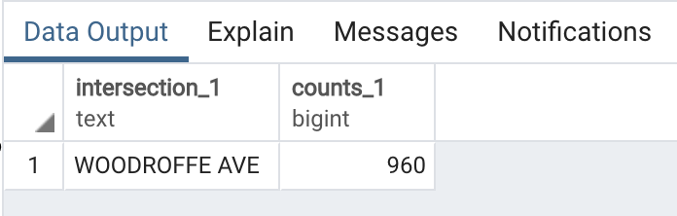

For instance, determine the neighbourhoods with the least accidents during evening rush hour.

**select l_dim.neighbourhood as neighbourhood,**

**h_dim.hour_start,**

**h_dim.hour_end,**

**count(*) as counts**

**from locations as l_dim, collision_fact as cf, hours as h_dim**

**where**

**cf.location_key = l_dim.location_key**

**and cf.hour_key = h_dim.hour_key**

**and (h_dim.hour_start between 16 and 19)**

**and (h_dim.hour_end between 16 and 19)**

**group by neighbourhood, h_dim.hour_start,**

**h_dim.hour_end**

**order by counts**

**limit 1;**

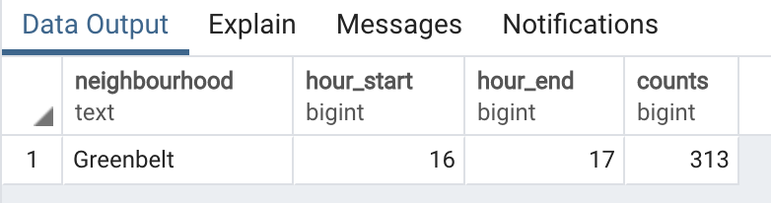

For instance, determine the intersections with the least accidents in fall, during dusk.

**select l_dim.intersection_1 as intersection_1,**

**h_dim.hour_start,**

**h_dim.hour_end,**

**h_dim.month,**

**count(*) as counts**

**from locations as l_dim, collision_fact as cf, hours as h_dim**

**where**

**cf.location_key = l_dim.location_key**

**and cf.hour_key = h_dim.hour_key**

**and (h_dim.hour_start between 16 and 19)**

**and (h_dim.hour_end between 16 and 19)**

**and (h_dim.month = 'September' or h_dim.month = 'October' or h_dim.month = 'November')**

**group by intersection_1,h_dim.hour_start,**

**h_dim.hour_end,h_dim.month**

**order by counts**

**limit 1;**

For instance, determine the sections of highways with the most accidents when visibility is poor.

**select l_dim.street_name, l_dim.intersection_1,l_dim.intersection_2,**

**w_dim.visibilitykm, count(*)**

**from collision_fact as cf, locations as l_dim, weather_data as w_dim**

**where cf.location_key = l_dim.location_key**

**and cf.weatherkey = w_dim.idkey**

**and visibilitykm <20.00 -- assumed**

**group by (l_dim.street_name, l_dim.intersection_1,l_dim.intersection_2,**

**w_dim.visibilitykm)**

**order by count desc**

**limit 1;**

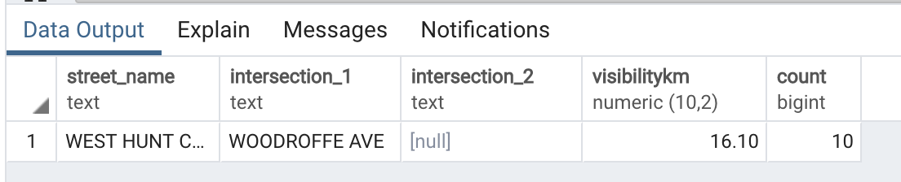

***5. Calculate trends over the years.***

**SELECT**

**SUM(F.FATAL_MEASURE) as NBR_Accident**

**FROM**

**collision_fact f, hours h, locations l**

**WHERE**

**l.neighbourhood like('Centertown') and f.location_key = l.location_key and h.hour_key = f.hour_key**

For instance, determine the monthly trends in adverse weather conditions over the four years.

**SELECT**

**h.year , h.month, w.conditions,**

**SUM(F.FATAL_MEASURE) as NBR_Accident**

**FROM**

**collision_fact f, hours h, weather_dimension w**

**WHERE**

**h.hour_key = f.hour_key and w.weatherkey=f.weatherkey**

**group by w.conditions, h.year, h.month**

**ORDER by h.year, h.month ASC**